Experiment No.:1
1. Title: Demonstrate inline, internal, and external JavaScript; use console methods; create a webpage showing user info and a welcome message.
2. Software/Tools Required:
- Visual Studio Code (VS Code)
- Google Chrome
- HTML5
- JavaScript
3. Theory: JavaScript is a client-side scripting language used to make web pages interactive and dynamic. It can be included in an HTML document in three ways:
- Inline JavaScript: JavaScript code is written directly inside an HTML element using event attributes like onclick.
- Internal JavaScript: JavaScript code is written inside the <script> tag within the HTML document.
In this experiment, Internal CSS is used to style the webpage with colorful headings, centered text, and a styled button. JavaScript is used to display a welcome message, show an alert on button click, and demonstrate console methods such as console.log(), console.info(), console.warn(), and console.error() for debugging.

4. Output:
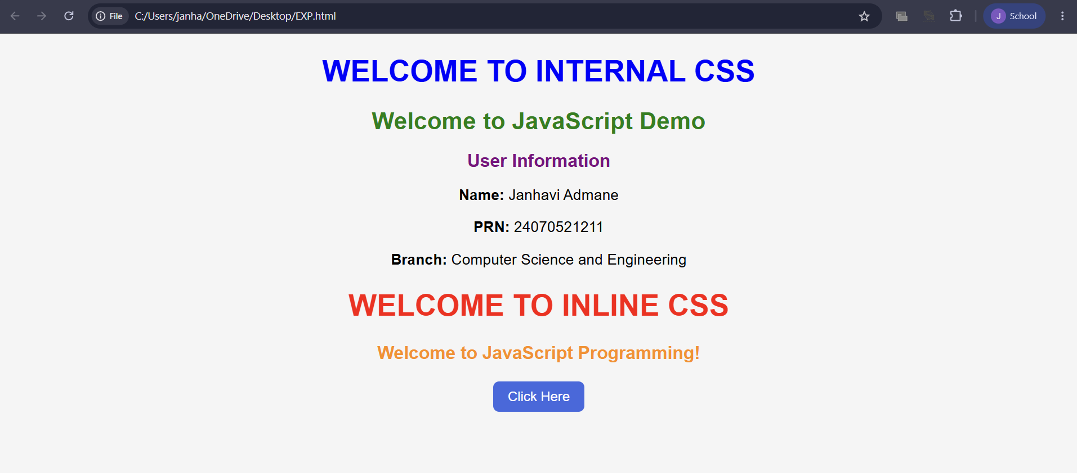

5. Result/Conclusion:
The experiment was successfully performed. The webpage correctly demonstrated the use of Inline, Internal, and External JavaScript, displayed the user information and welcome message, and used Internal CSS for styling. JavaScript console methods executed successfully, and the alert message appeared when the button was clicked. The objectives of the experiment were achieved successfully.

CASE STUDY 1
AIM:
Create a webpage for the college department and link the student information and write a JavaScript program to display “Welcome to SIT Nagpur”.
PROGRAM CODE:
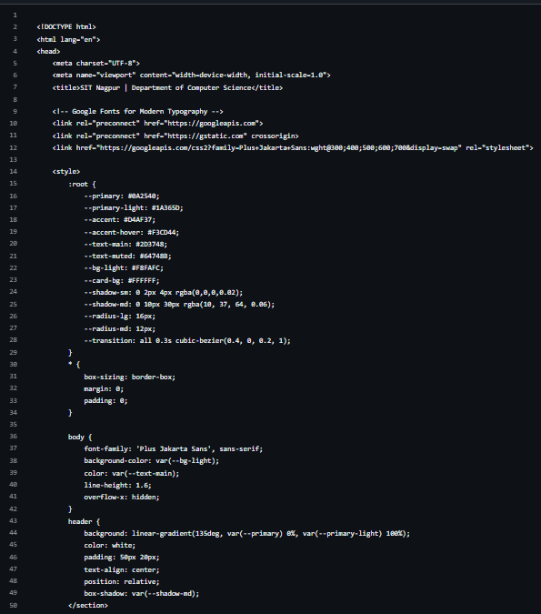
OUTPUT:
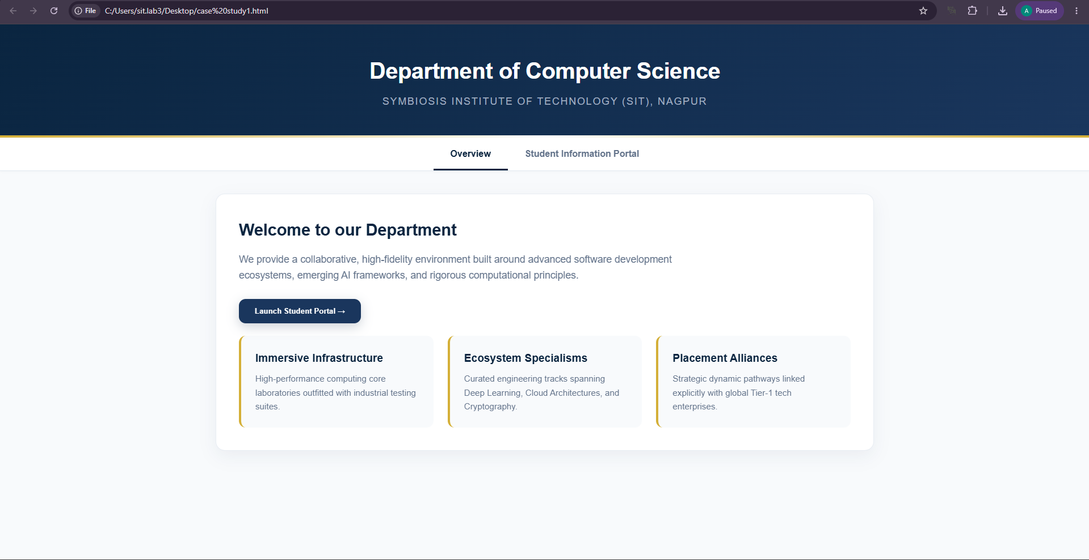
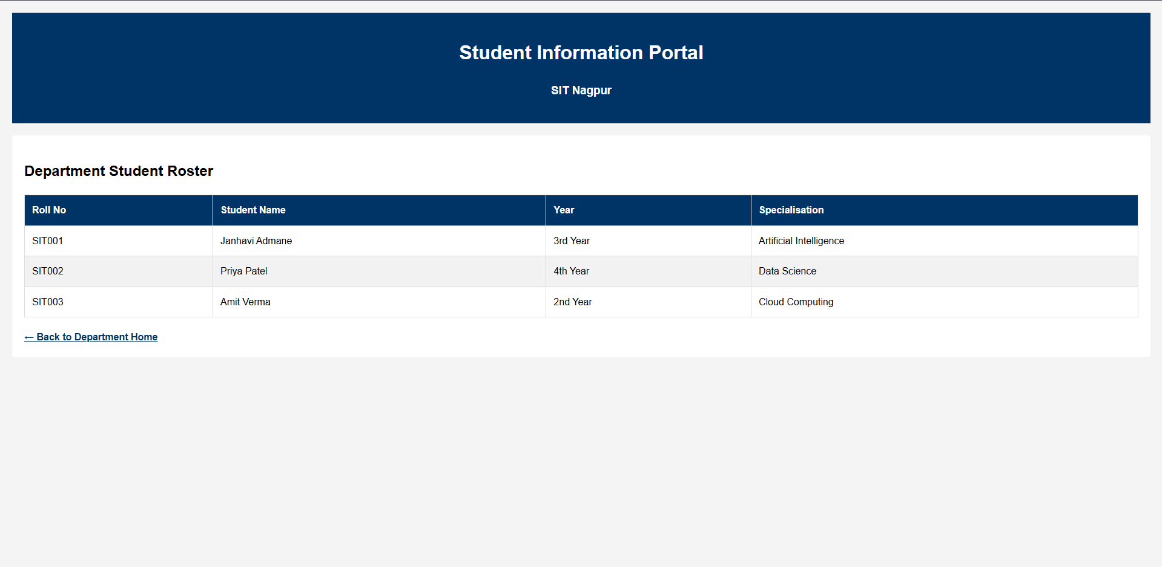
RESULT:
A webpage for the college department was successfully created using HTML, CSS, and JavaScript. Student information was linked and displayed correctly, and the JavaScript program successfully displayed the message "Welcome to SIT Nagpur" on the webpage. Thus, the aim of creating a college department webpage and implementing JavaScript functionality was achieved successfully.

EXPERIMENT 2

AIM:
To use var, let, and const, and demonstrate ES6 features like template literals and destructuring by building a billing calculator.
Software/Tools Required:
- Visual Studio Code (VS Code)
- Web Browser (Google Chrome/Microsoft Edge)
- HTML5
- JavaScript (ES6)
Theory:
JavaScript ES6 (ECMAScript 2015) introduced several modern features that make programming more efficient, readable, and easier to maintain. Among these features are var, let, and const, which are used for variable declaration. The var keyword has function scope and allows variables to be redeclared and updated. The let keyword provides block scope and allows variables to be updated but not redeclared within the same scope. The const keyword is also block-scoped and is used to declare constants whose values cannot be reassigned after initialization.
Template literals are another important ES6 feature that simplify string creation and formatting. They use backticks ( ) instead of quotation marks and allow variables and expressions to be embedded directly into strings using ${expression}. This eliminates the need for string concatenation and improves code readability.
Destructuring is a convenient JavaScript feature that enables the extraction of values from arrays or properties from objects into separate variables. It reduces repetitive code, makes variable assignment more concise, and improves code clarity, especially when working with complex data structure

Output:
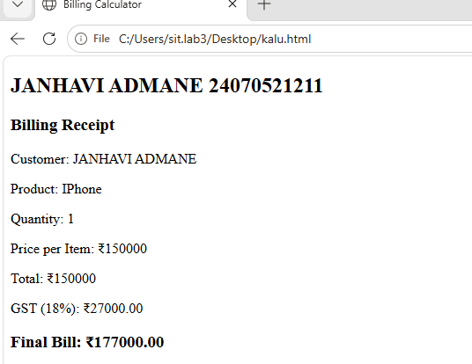

Result:
Successfully implemented a billing calculator using JavaScript ES6 features, including var, let, const, template literals, and destructuring, to calculate and display billing details

CASE STUDY 2
AIM:
Develop the webpage for an online shopping website with using html,css and html tags and calculate bill,customer name,mobile no,invoice no,product no,quantity(kg),rate per kg,discount,GST,packing charges,payment mode(cash/card/UPI), Membership(yes/no).
PROGRAM CODE:

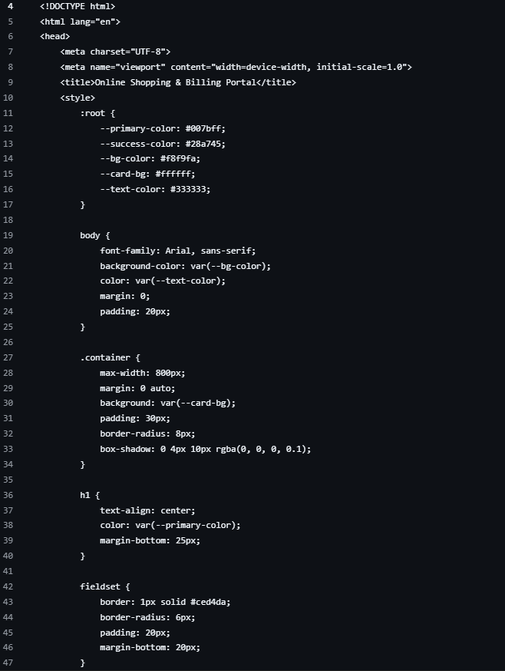
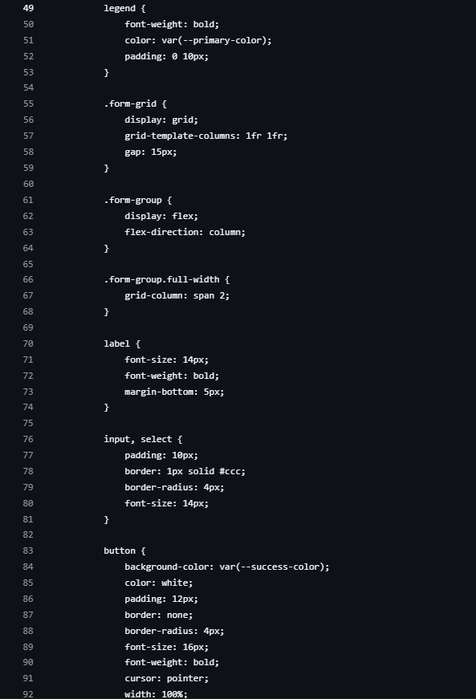

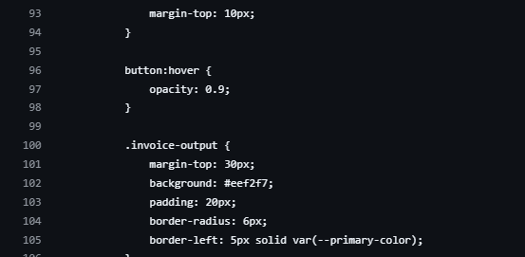

OUTPUT:
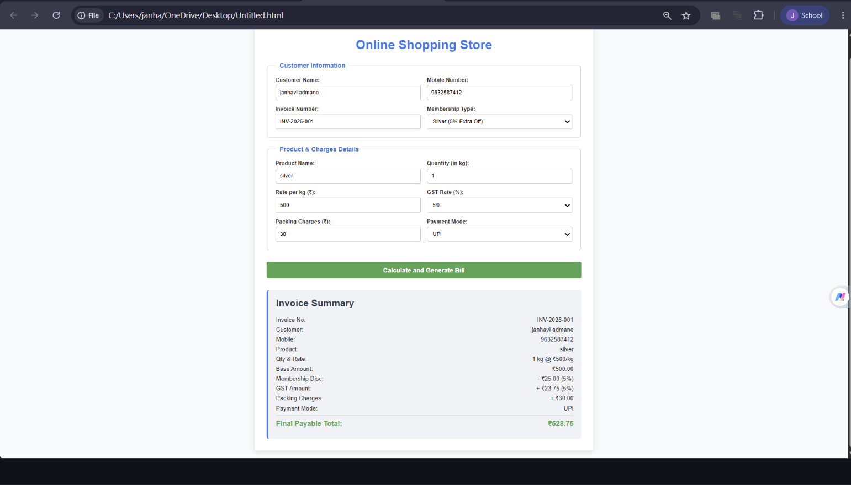
RESULT:
The online shopping billing webpage was successfully developed using HTML, CSS, and JavaScript. The program accepted customer and product details, calculated the total bill including discount, GST, and packing charges, and displayed the final invoice correctly. It demonstrated the use of user input, arithmetic calculations, objects, template literals, and object destructuring in JavaScript.

EXPERIMENT 3
AIM:
To implement JavaScript control structures and form validation by creating a grading system based on user-entered marks.
Software/Tools Required:
- Visual Studio Code (VS Code)
- Web Browser (Google Chrome/Microsoft Edge)
- HTML5
- JavaScript (ES6)
Theory:
JavaScript is a widely used scripting language that enables interactive and dynamic behavior on web pages. One of its key features is the use of control structures, such as if, else if, else, and switch, which allow programs to make decisions based on specified conditions. These control structures help in executing different blocks of code depending on the values provided by the user, making applications more intelligent and responsive.
Another important concept in web development is form validation, which ensures that user input is accurate, complete, and within the expected range before it is processed. Validation helps prevent invalid or incomplete data from affecting the application's functionality. It checks conditions such as empty input fields, non-numeric values, and marks entered outside the valid range (0–100). This improves data integrity and enhances the overall user experience.
In this experiment, a grading system is developed using HTML and JavaScript. The user enters marks for different subjects through a form, and JavaScript validates the input before performing calculations. After successful validation, the program computes the total marks, percentage, grade, and pass/fail status. The grade is determined using conditional statements based on predefined percentage ranges, while the pass/fail status is decided according to the minimum passing criteria. This experiment demonstrates the practical application of JavaScript control structures and form validation in building an interactive and reliable web application.

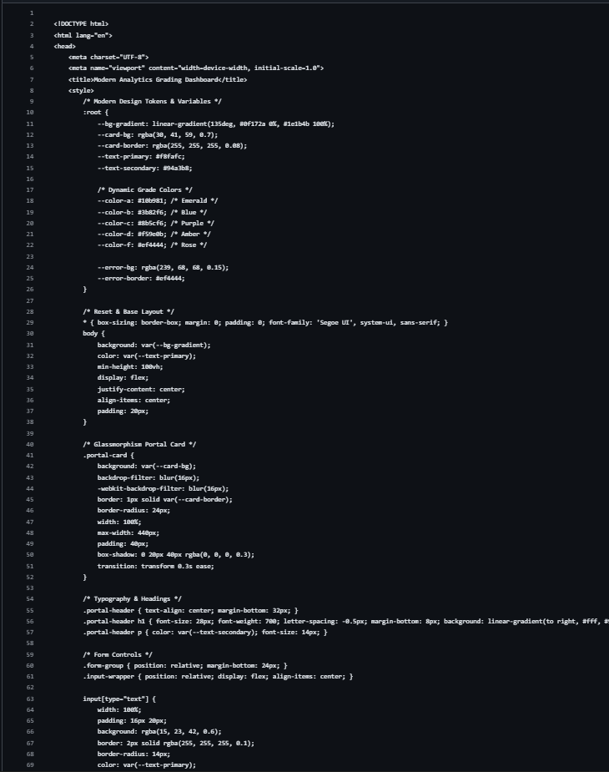

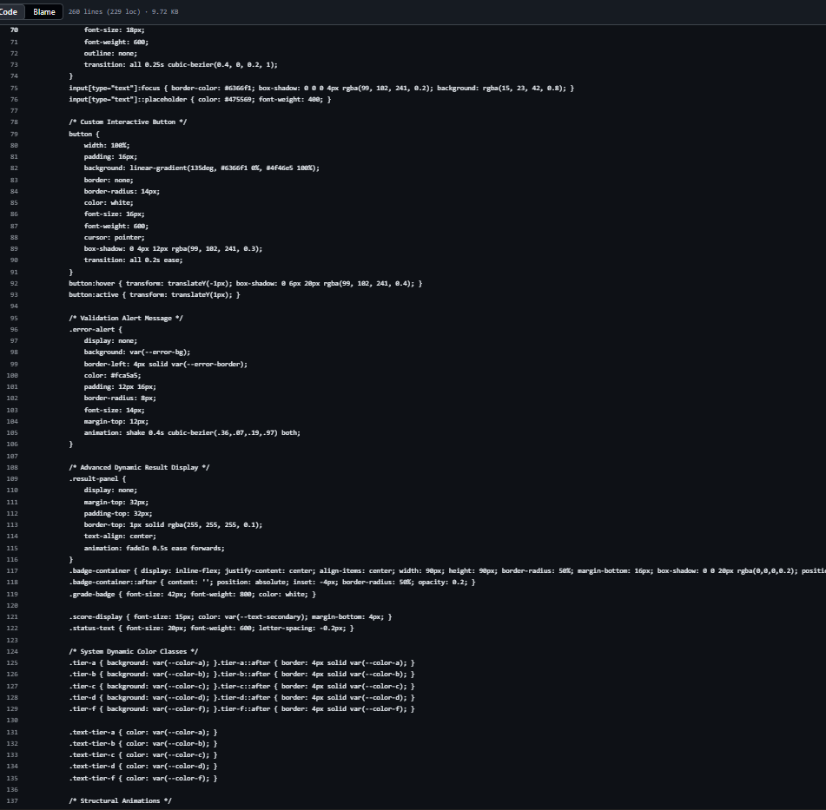

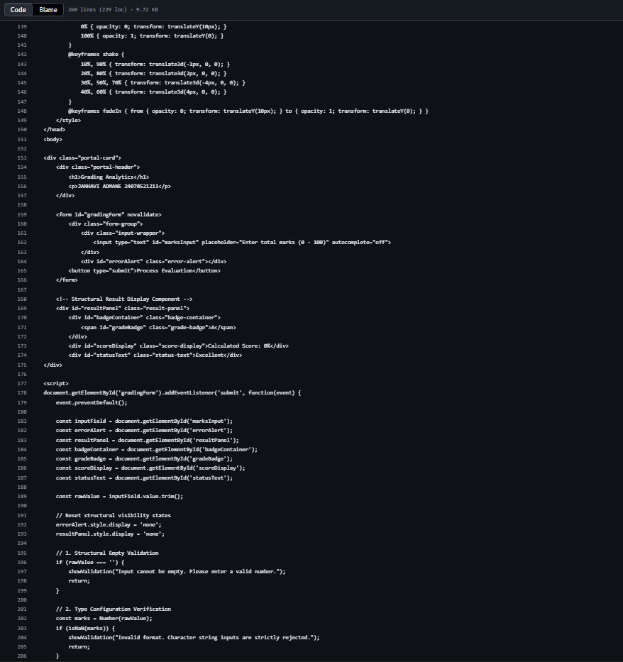
Output:
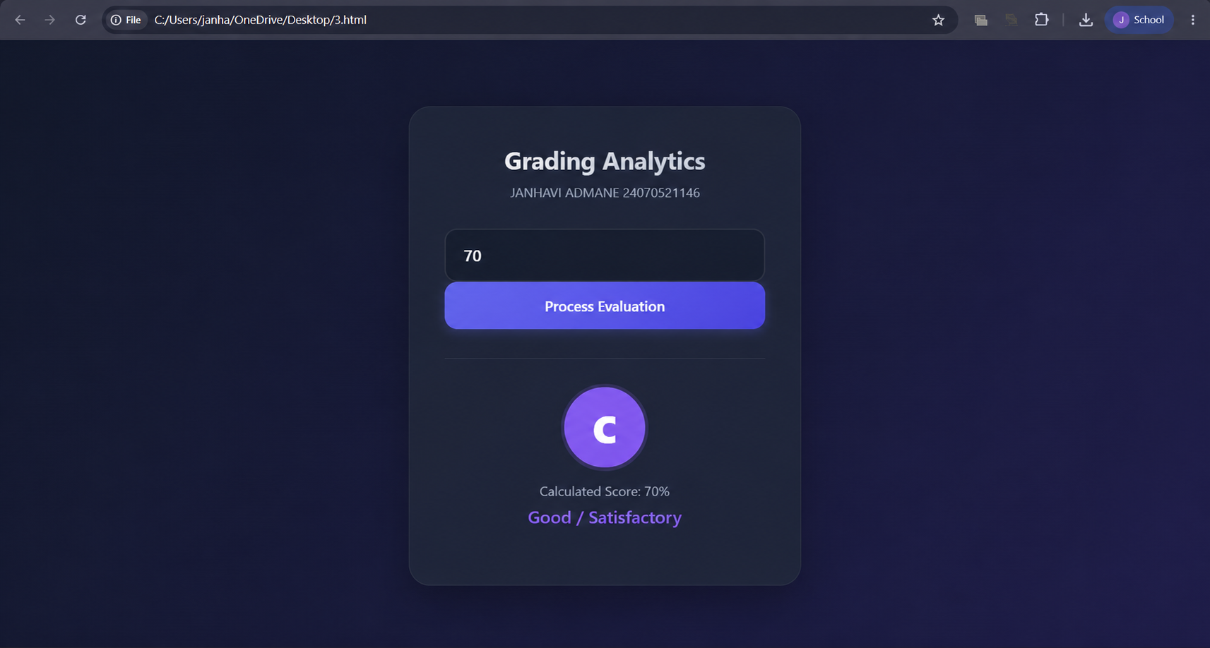
Result:
Successfully implemented JavaScript control structures and form validation to create a grading system that validates user input, calculates the total marks, percentage, grade, and pass/fail status accurately.

CASE STUDY 3

AIM:
Scholarship Eligibility,A college awards scholarships based on marks. Below 50-Not Eligible, 50-69-Bronze,70-84-Silver,85-94-Gold,95-100-Platinum.
PROGRAM CODE:

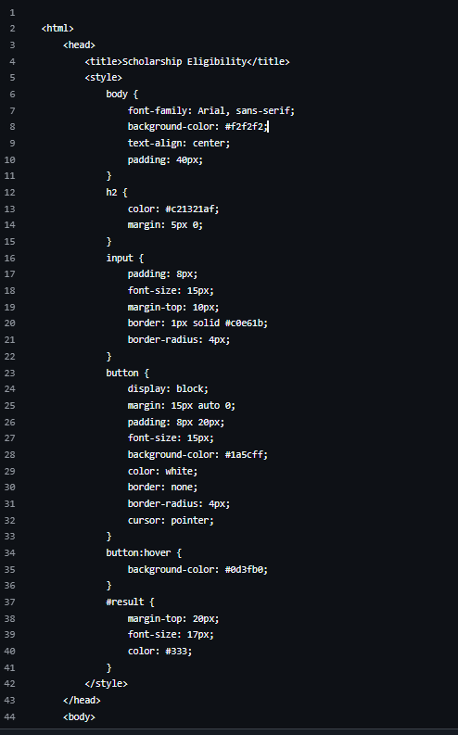
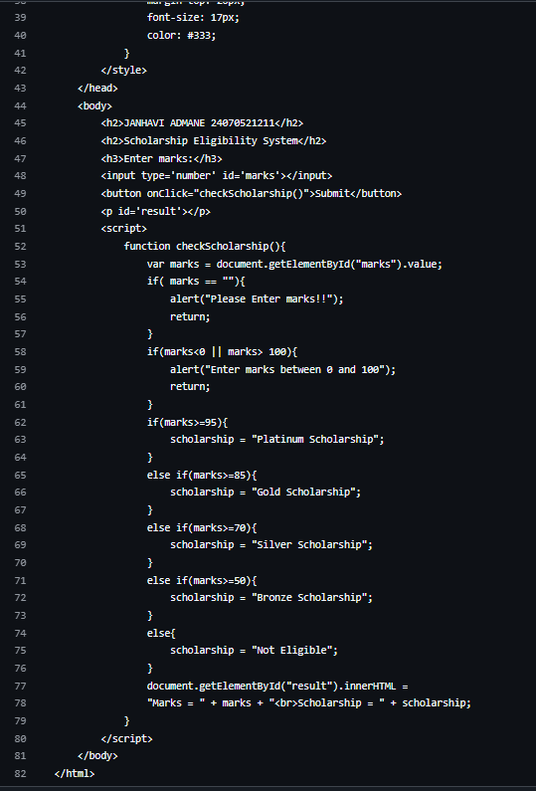
OUTPUT:
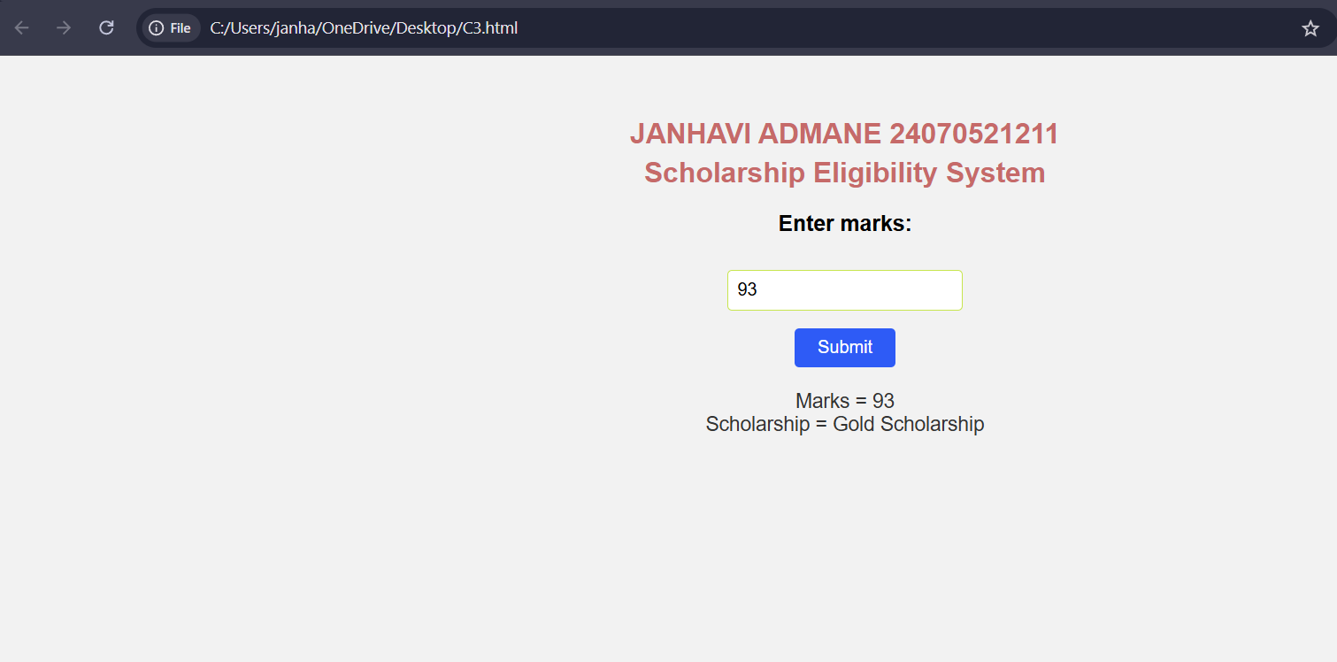

RESULT:
The Scholarship Eligibility was successfully implemented using JavaScript. The program validated the user input, assigned eligibility marks using if-else control structures, and displayed the correct Eligibility awards based on the entered marks. It effectively demonstrated the use of control structures and form validation in web development.

EXPERIMENT 4
AIM:
Use function types, scope and closures; apply try-catch; build a palindrome checker
Software/Tools Required:
- Visual Studio Code (VS Code)
- Web Browser (Google Chrome/Microsoft Edge)
- HTML
- JavaScript (ES6)
Theory:
A palindrome is a word, number, or sentence that reads the same forward and backward, such as MADAM, LEVEL, and 121. A palindrome checker is a program that checks whether the given input is a palindrome or not by comparing the original string with its reverse.
In JavaScript, different types of functions, such as function declarations, function expressions, and arrow functions, can be used to implement the palindrome checker. Variable scope determines where variables can be accessed in the program, while closures allow an inner function to access variables from its outer function.
The try-catch statement is used for exception handling and helps manage errors, such as invalid or empty input, without stopping the execution of the program. Thus, a palindrome checker demonstrates the concepts of functions, scope, closures, and error handling in JavaScript.

Output:
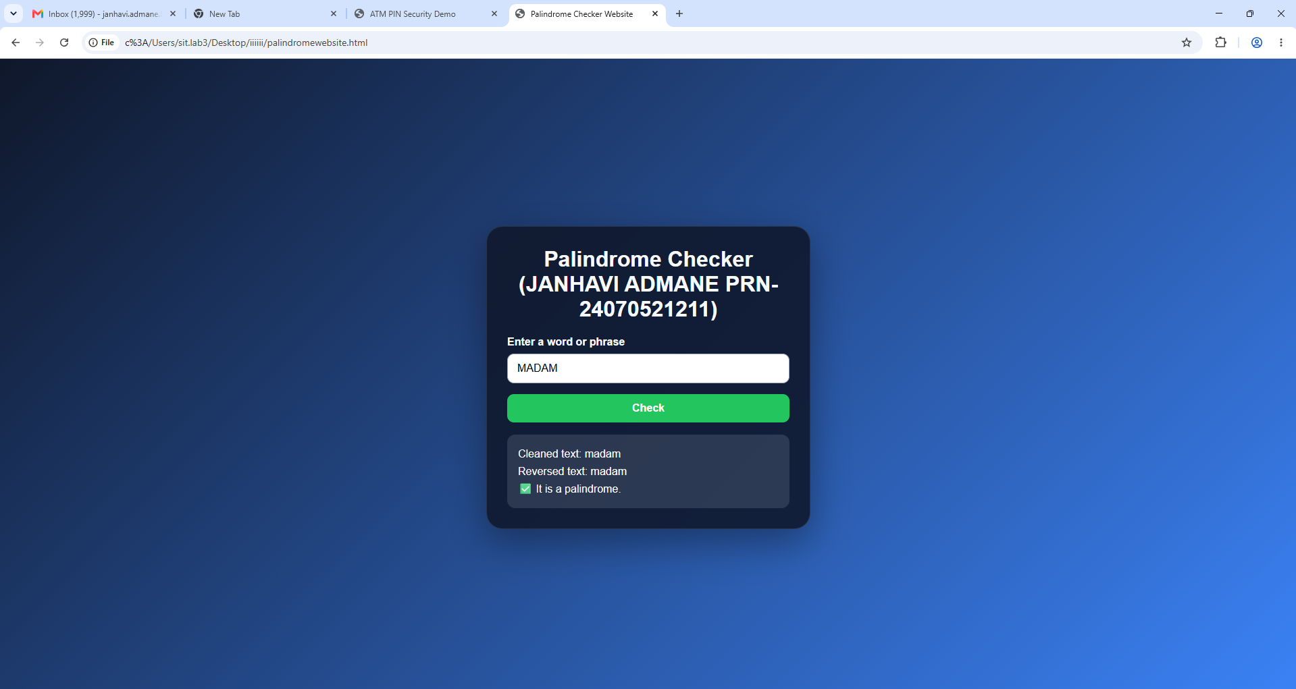

Result:
Successfully implemented a Palindrome detector using JavaScript ES6 features, including var, let, const, template literals, and destructuring, to find and display whether the given text or number is a palindrome or not.

CASE STUDY 4
AIM:
The ATM system verifies if the pin is palindrome. If the palindrome displays a security message. To implement this create a function to reverse the entered pin number and another function to check if it is palindrome. use function declaration, function expression, arrow function and demonstrate scope and closure concepts.
PROGRAM CODE:

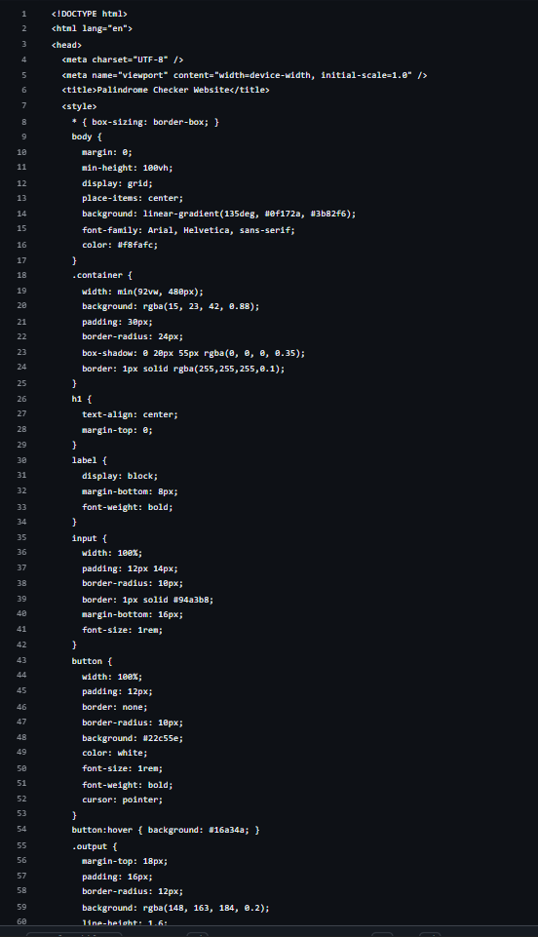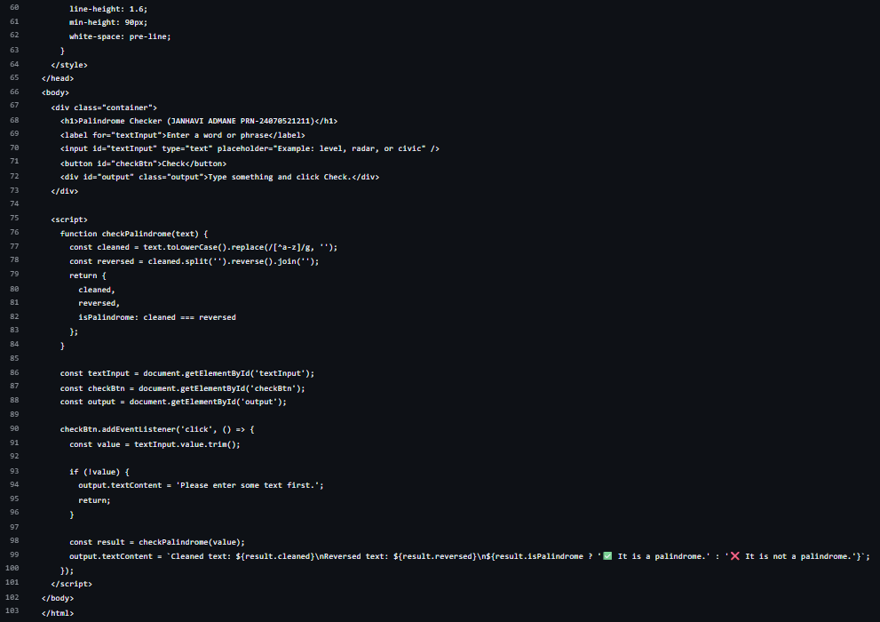

OUTPUT:
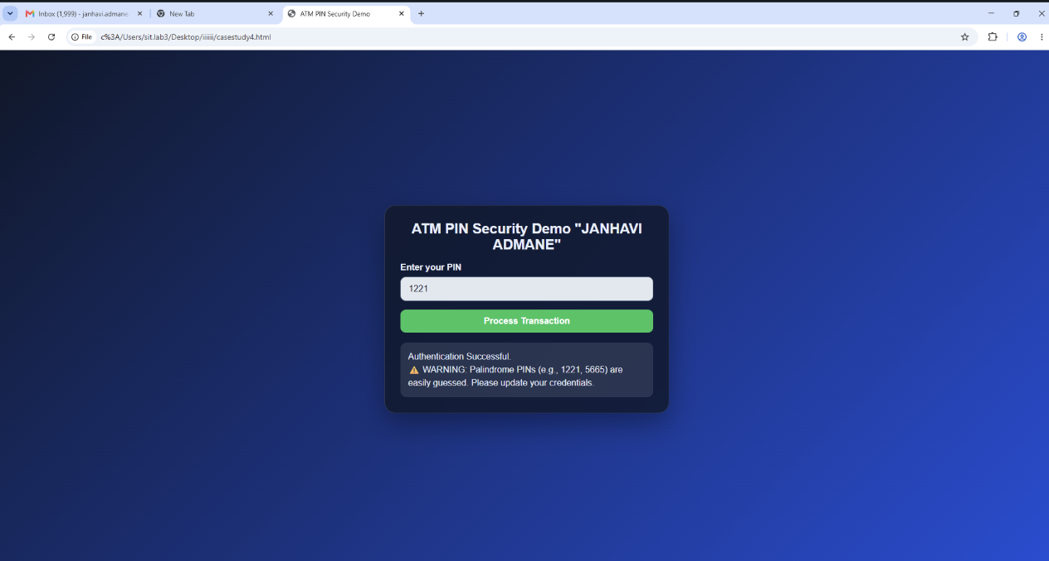
RESULT:
Successfully implemented a ATM pin Palindrome detector using JavaScript ES6 features, including var, let, const, template literals, and destructuring, to find and display whether the given ATM pin is a palindrome or not.

EXPERIMENT 5
AIM:
Apply array methods and object handling; create a cart total calculator with discount logic.
SOFTWARE/TOOLS REQUIRED:
- Visual Studio Code (VS Code)
- Web Browser (Google Chrome/Microsoft Edge)
- HTML5
- JavaScript (ES6)
THEORY:
JavaScript is a widely used scripting language that enables dynamic and interactive functionality in web applications. It provides various features for handling and manipulating data, including arrays and objects. Arrays are used to store multiple values in a single variable, while objects store related data in the form of key-value pairs. Together, arrays and objects are useful for representing structured information such as products in a shopping cart.
JavaScript provides several built-in array methods that simplify data processing and manipulation. Methods such as map(), reduce(), and forEach() can be used to perform operations on array elements efficiently. The map() method can be used to calculate the total price of individual products, while reduce() can be used to calculate the overall cart subtotal. The forEach() method can be used to iterate through the cart items and display their details.
Another important concept demonstrated in this experiment is conditional logic for applying discounts. Using if, else if, and else statements, different discount percentages can be applied depending on the total purchase amount. This allows the shopping cart to automatically determine the appropriate discount and calculate the final payable amount.
In this experiment, a cart total calculator is developed using JavaScript. The cart contains multiple product objects with properties such as product name, price, and quantity. JavaScript processes these objects using array methods to calculate individual item totals and the overall subtotal. Based on the subtotal, a suitable discount is applied using conditional statements. Finally, the program calculates and displays the subtotal, discount amount, and final cart total. This experiment demonstrates the practical application of JavaScript arrays, objects, array methods, and conditional statements in developing a simple and interactive shopping cart system.
OUTPUT:
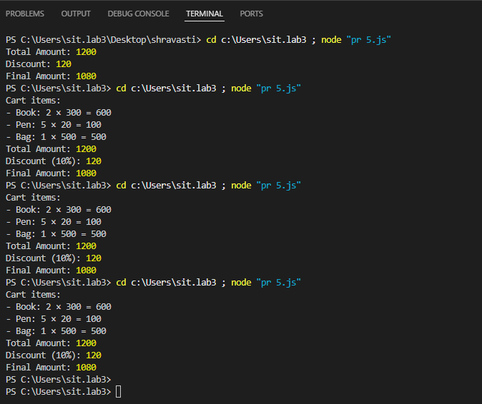
RESULT/CONCLUSION:
Thus, the experiment demonstrates the use of JavaScript arrays, objects, array methods, and conditional statements to calculate a shopping cart total and apply discounts. It provides a basic understanding of data handling and calculation using JavaScript.

CASE STUDY 5
1. Experiment Title:
Study and Implementation of Arrays and Loops in JavaScript
2. Software/Tools Required:
- HTML5
- CSS3
- JavaScript
- Web Browser
- VS Code / any text editor
3. Experiment Program Code:
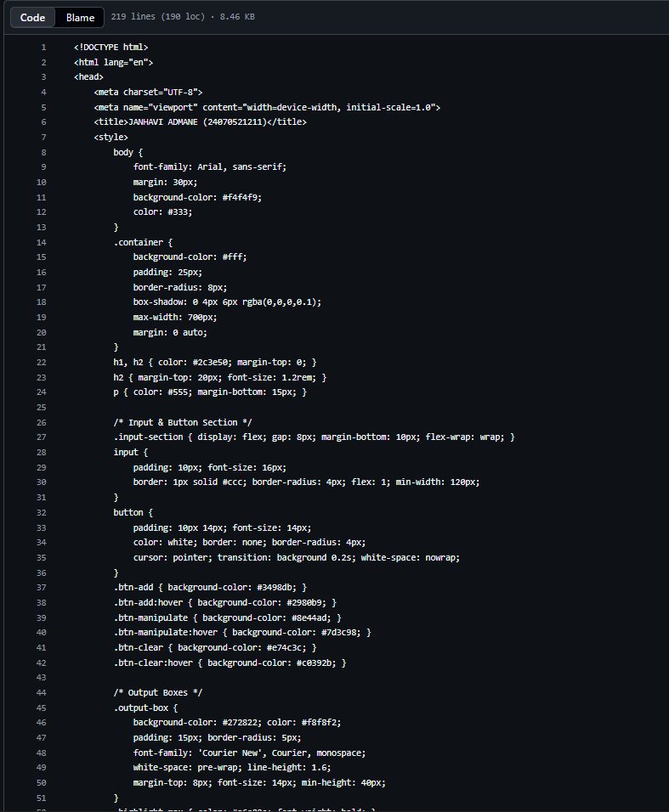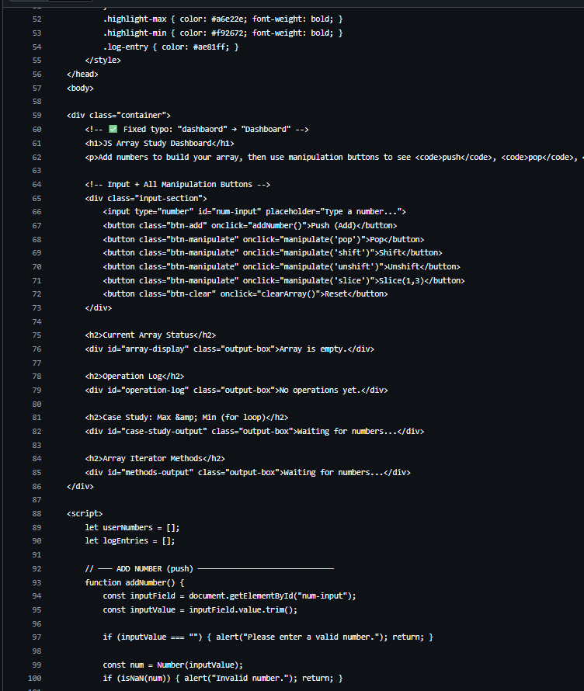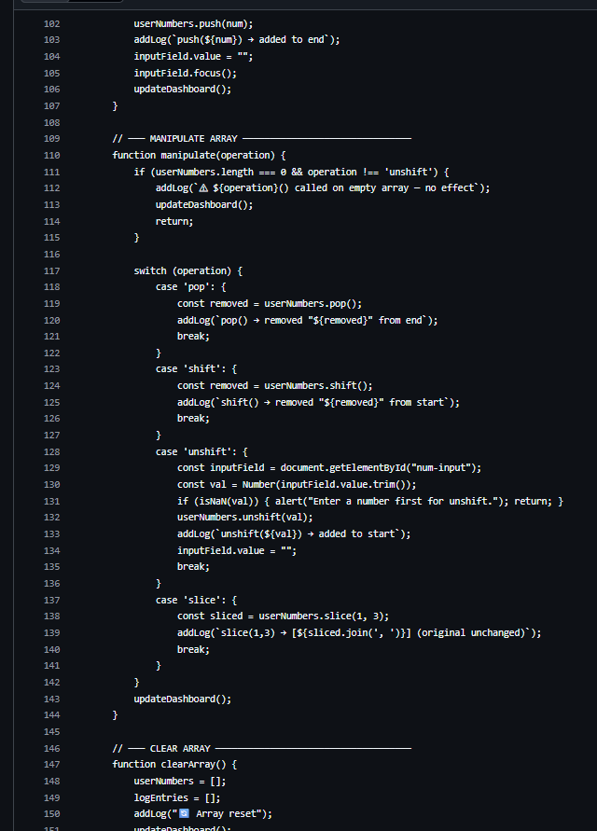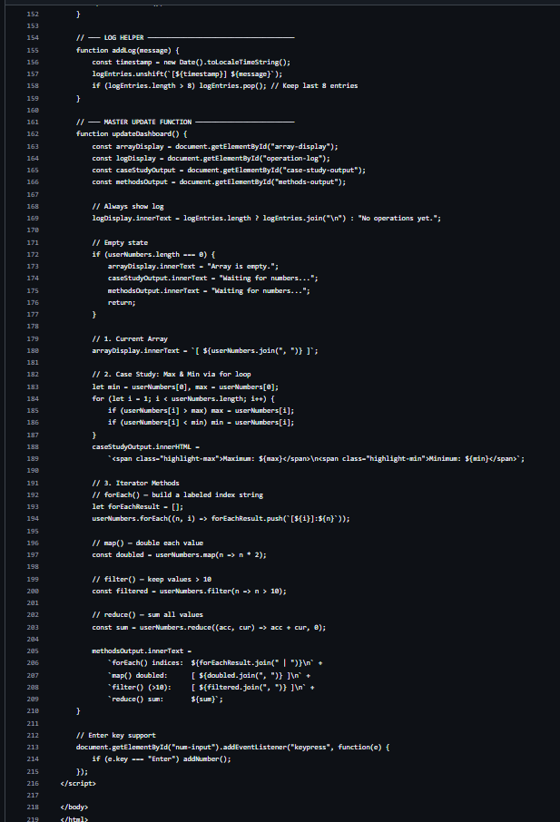

4.Output: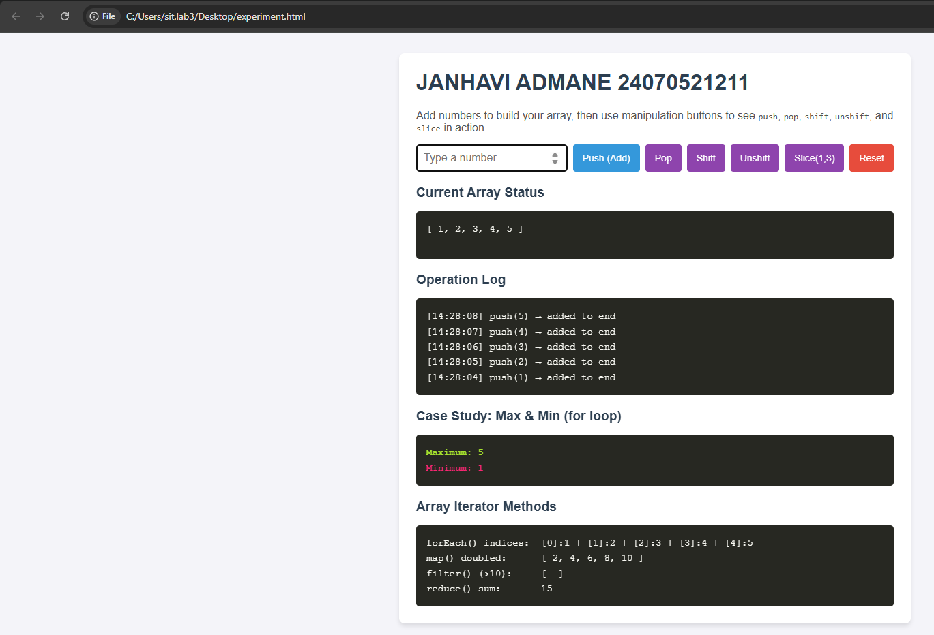

5. Result/Conclusion:
The experiment was successfully performed to study arrays and loops in JavaScript. The maximum and minimum values of an array were successfully determined using JavaScript loops.

EXPERIMENT 6
AIM:
Use string functions and regex for email validation, data extraction and text analysis.
SOFTWARE/TOOLS REQUIRED:
- Visual Studio Code (VS Code)
- Web Browser (Google Chrome/Microsoft Edge)
- HTML5
- JavaScript (ES6)
THEORY:
String functions and regular expressions (Regex) are important techniques used for processing, manipulating, validating, and analyzing text data. String functions are built-in functions that perform operations on strings, such as finding the length of a string, converting text to uppercase or lowercase, joining strings, searching for specific words or characters, extracting substrings, replacing text, splitting a string into parts, and removing unnecessary spaces. These functions are useful for basic text manipulation and data processing.
Regular Expression (Regex) is a sequence of characters that defines a specific search pattern. It is mainly used to search, match, validate, extract, and replace text according to a particular pattern. Regex is commonly used for email validation, where it can check whether an email follows a proper format such as student@gmail.com. It can also be used to extract information such as phone numbers, dates, URLs, PIN codes, and other structured data from large amounts of text. Common Regex symbols include ^ for the beginning of a string, $ for the end, + for one or more occurrences, * for zero or more occurrences, \d for digits, and [A-Z] for uppercase letters.
String functions and Regex can also be used together for text analysis. For example, a program can convert text to lowercase, remove unnecessary spaces and punctuation, split the text into individual words, count words, and then use Regex to identify emails, phone numbers, or other patterns. These techniques are widely used in data cleaning, form validation, web scraping, Natural Language Processing (NLP), log analysis, and information extraction. In simple terms, string functions are mainly used for basic text manipulation, while Regex is used for complex pattern matching, validation, and data extraction.
OUTPUT: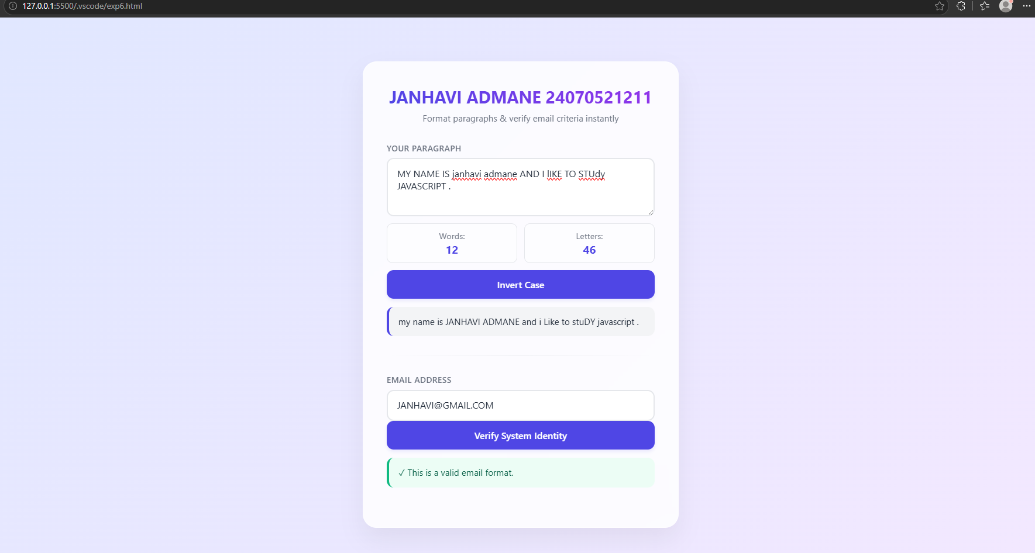
RESULT/CONCLUSION:
In conclusion, string functions and regular expressions are powerful tools for handling and analyzing text data. String functions help perform basic operations such as searching, modifying, splitting, and formatting strings, while regular expressions are useful for pattern matching, validation, and extracting specific information from text. Together, they make tasks such as email validation, data extraction, and text analysis easier, faster, and more efficient.

Case Study 6
1. Experiment Title:
Study and Implementation of String Operations, String Manipulation Methods, and Vowel Counting in JavaScript
2. Software/Tools Required:
- HTML5
- CSS3
- JavaScript
- Web Browser
- VS Code / any text editor
3. Experiment Program Code:
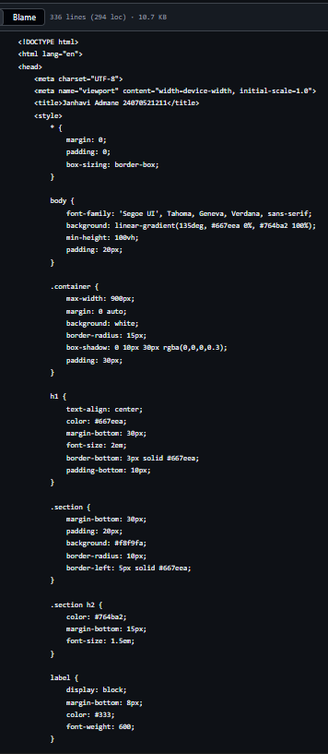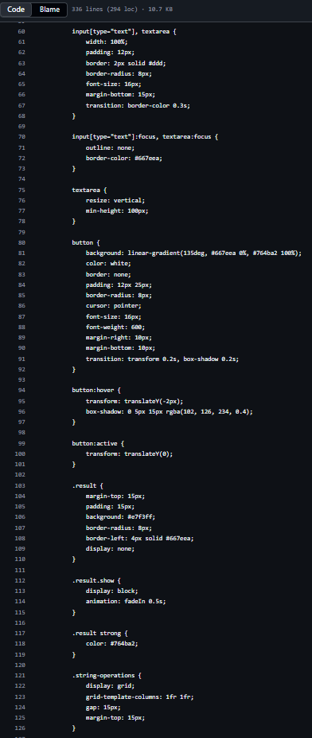
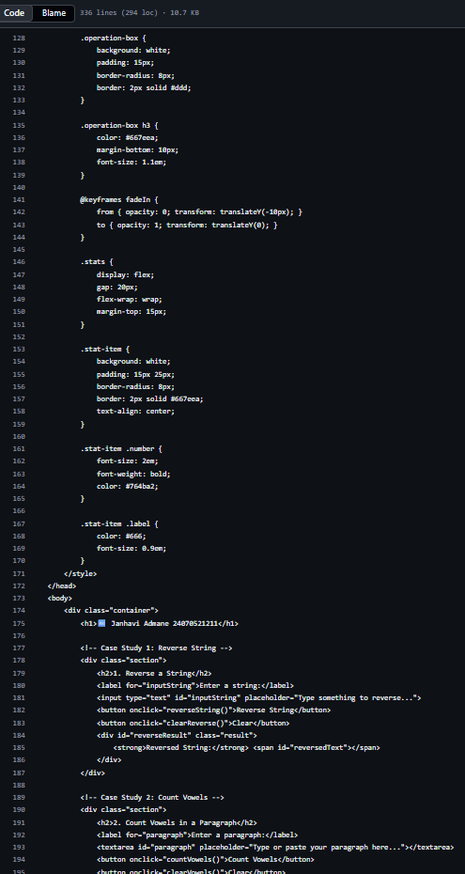
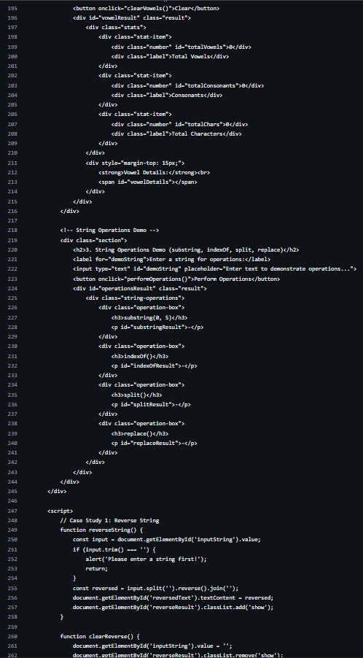
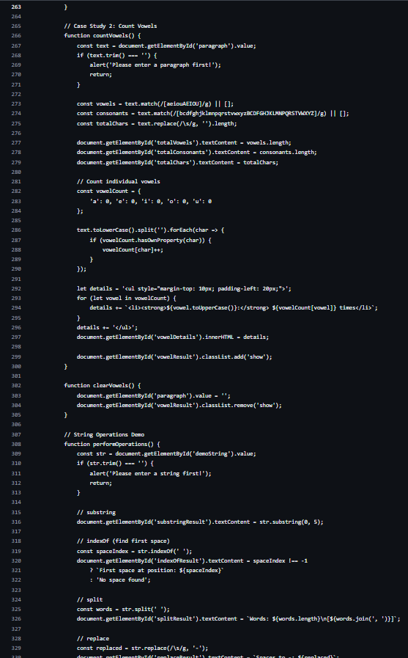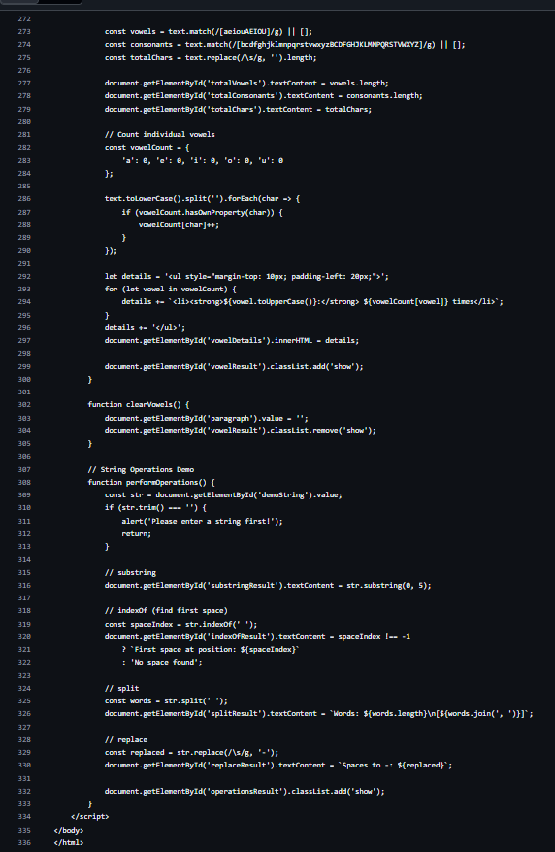

- Output:
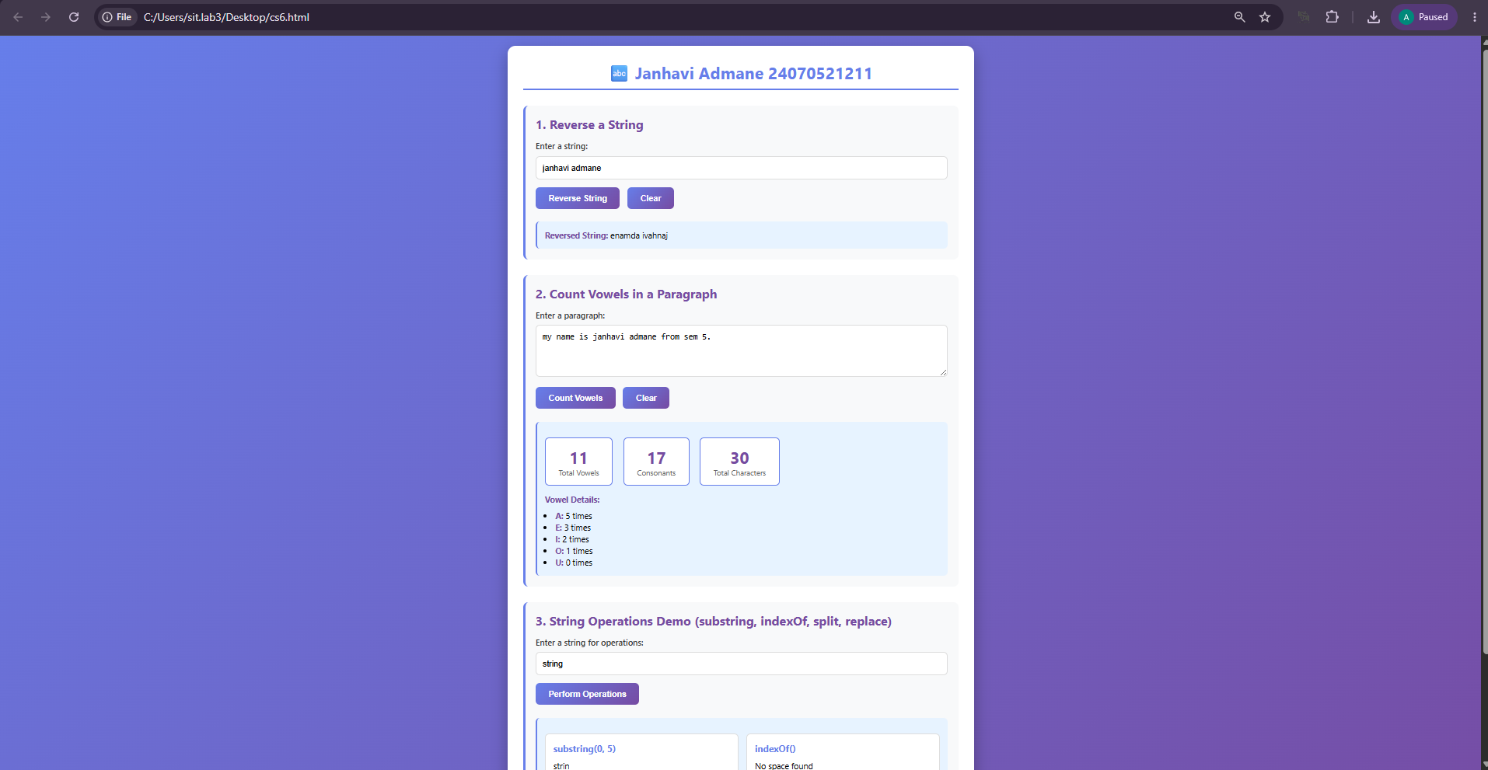
5. Result/Conclusion:
The experiment was successfully performed to study string operations and manipulation methods in JavaScript. The string was successfully reversed and the number of vowels was calculated.

EXPERIMENT 7
AIM:
Perform DOM traversal and updates; develop a to-do list app with add, edit, and delete features.
SOFTWARE/TOOLS REQUIRED:
- Visual Studio Code (VS Code)
- Web Browser (Google Chrome/Microsoft Edge)
- HTML5
- JavaScript (ES6)
THEORY:
The Document Object Model (DOM) is a programming interface that represents an HTML document as a tree structure of elements. JavaScript uses the DOM to access, modify, create, and delete HTML elements dynamically. DOM traversal means navigating through different elements such as parent, child, and sibling elements. JavaScript provides methods like getElementById(), querySelector(), and querySelectorAll() to select elements.
DOM updates allow JavaScript to change webpage content without reloading the page. Methods such as createElement() are used to create new elements, appendChild() adds elements to the webpage, textContent changes the content, and remove() deletes an element. These features are useful for creating interactive web applications.
A To-Do List application is a simple example of DOM manipulation. The user enters a task and clicks the Add button, after which JavaScript creates and displays a new list item. The Edit button allows the user to modify the task, while the Delete button removes it from the list. Thus, the application demonstrates DOM traversal and dynamic updates using JavaScript.

OUTPUT:
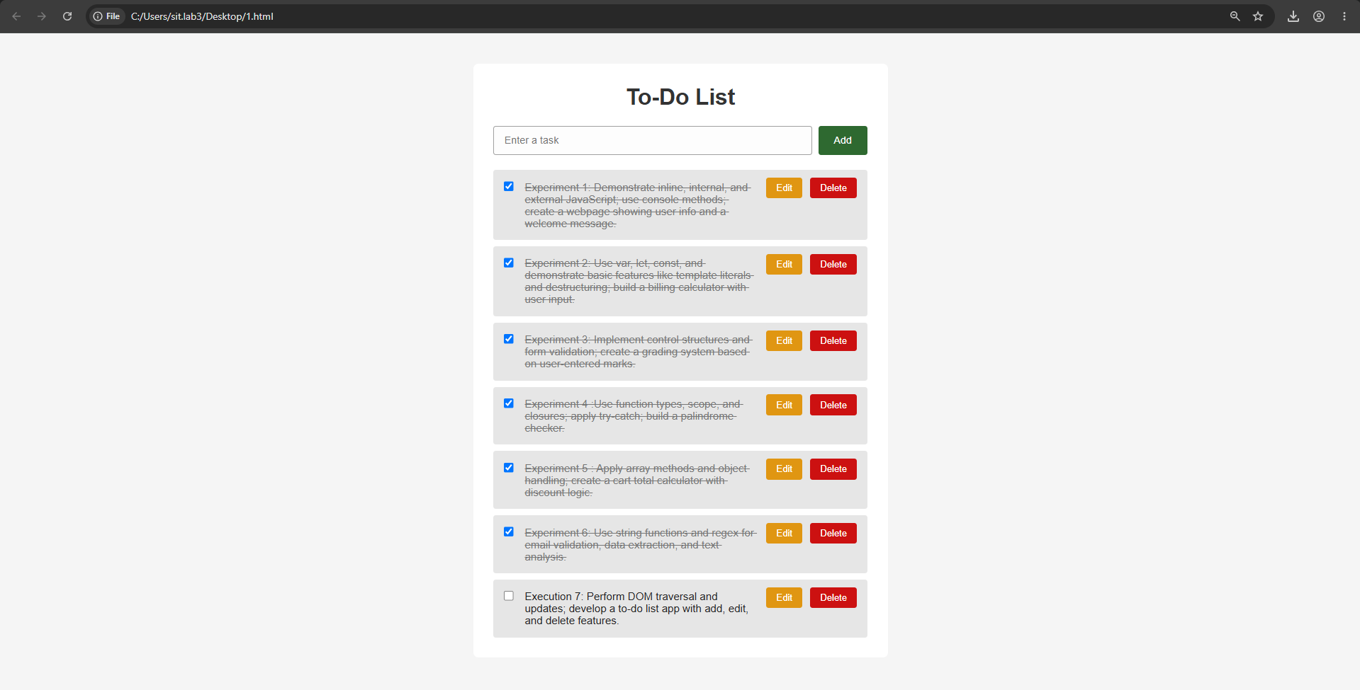
RESULT/CONCLUSION:
In conclusion, DOM traversal and manipulation are powerful features of JavaScript for creating interactive and dynamic web pages. DOM methods help access, create, modify, and remove HTML elements, while event handling allows the webpage to respond to user actions. Using these concepts, a To-Do List application with add, edit, and delete features can be implemented easily and efficiently.

Case Study 7
1. Experiment Title:
Study and Implementation of Event Handling, Form Validation, and Dynamic DOM Manipulation in JavaScript
2. Software/Tools Required:
- HTML5
- CSS3
- JavaScript
- Web Browser
- VS Code / any text editor
3. Experiment Program Code:
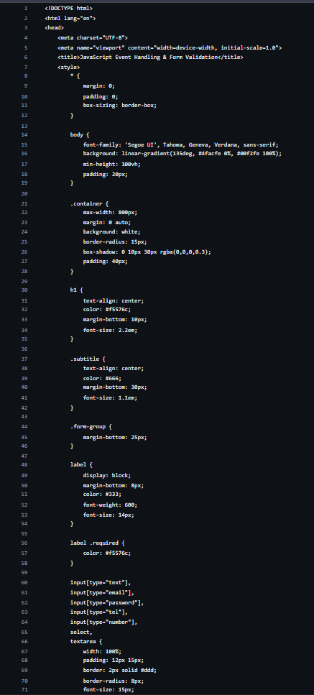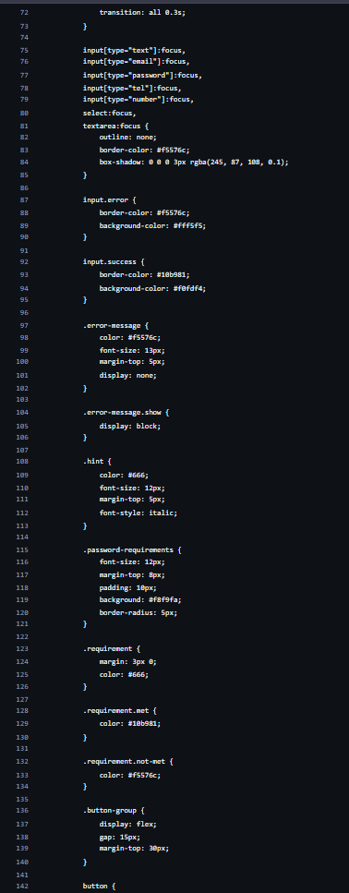
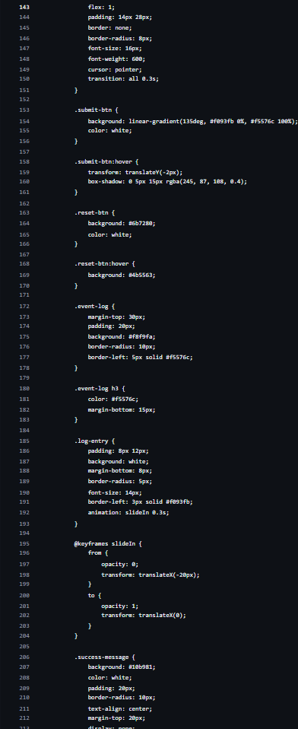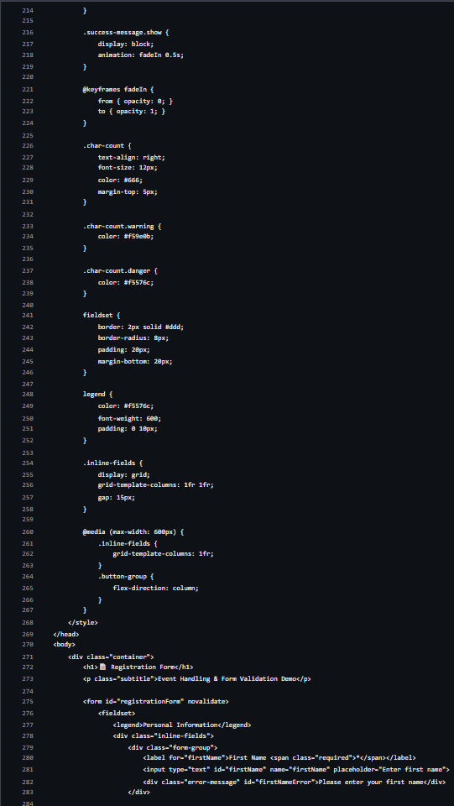
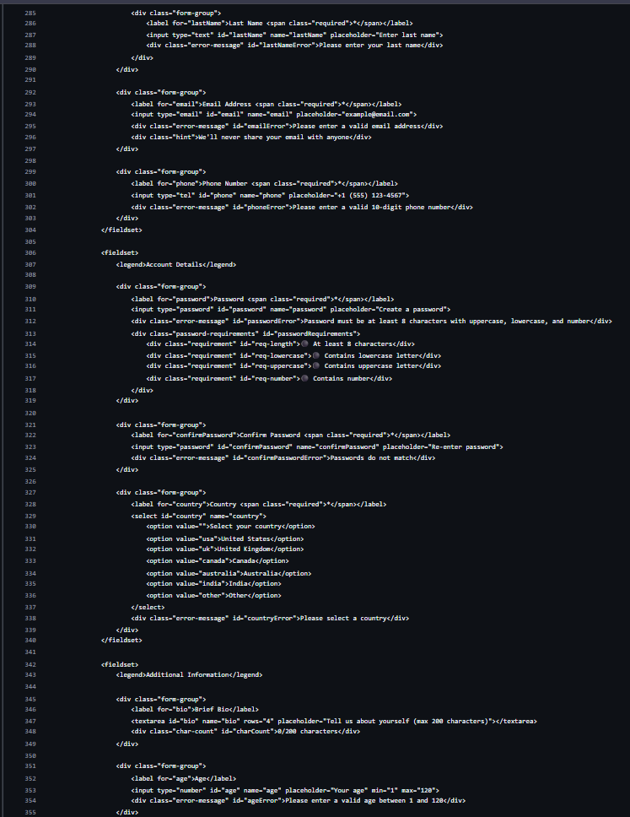
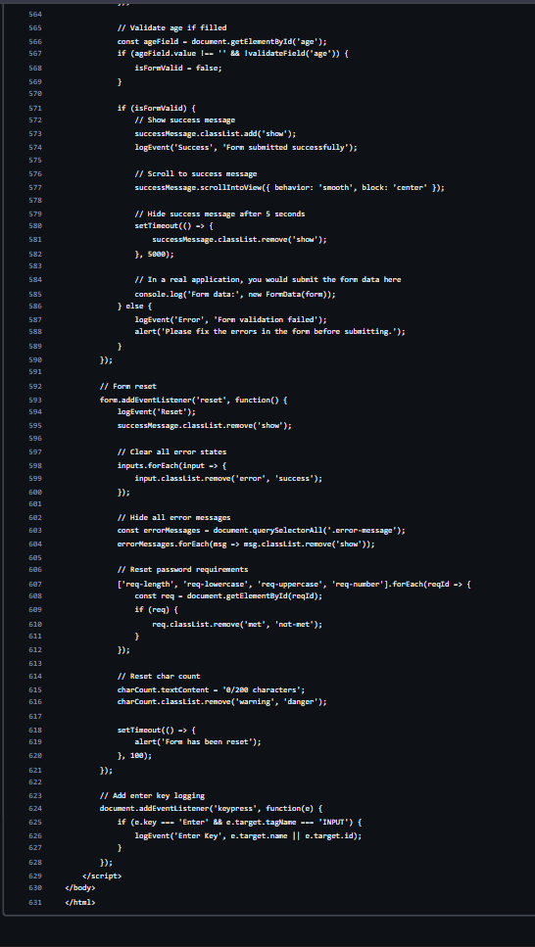
4. Output:
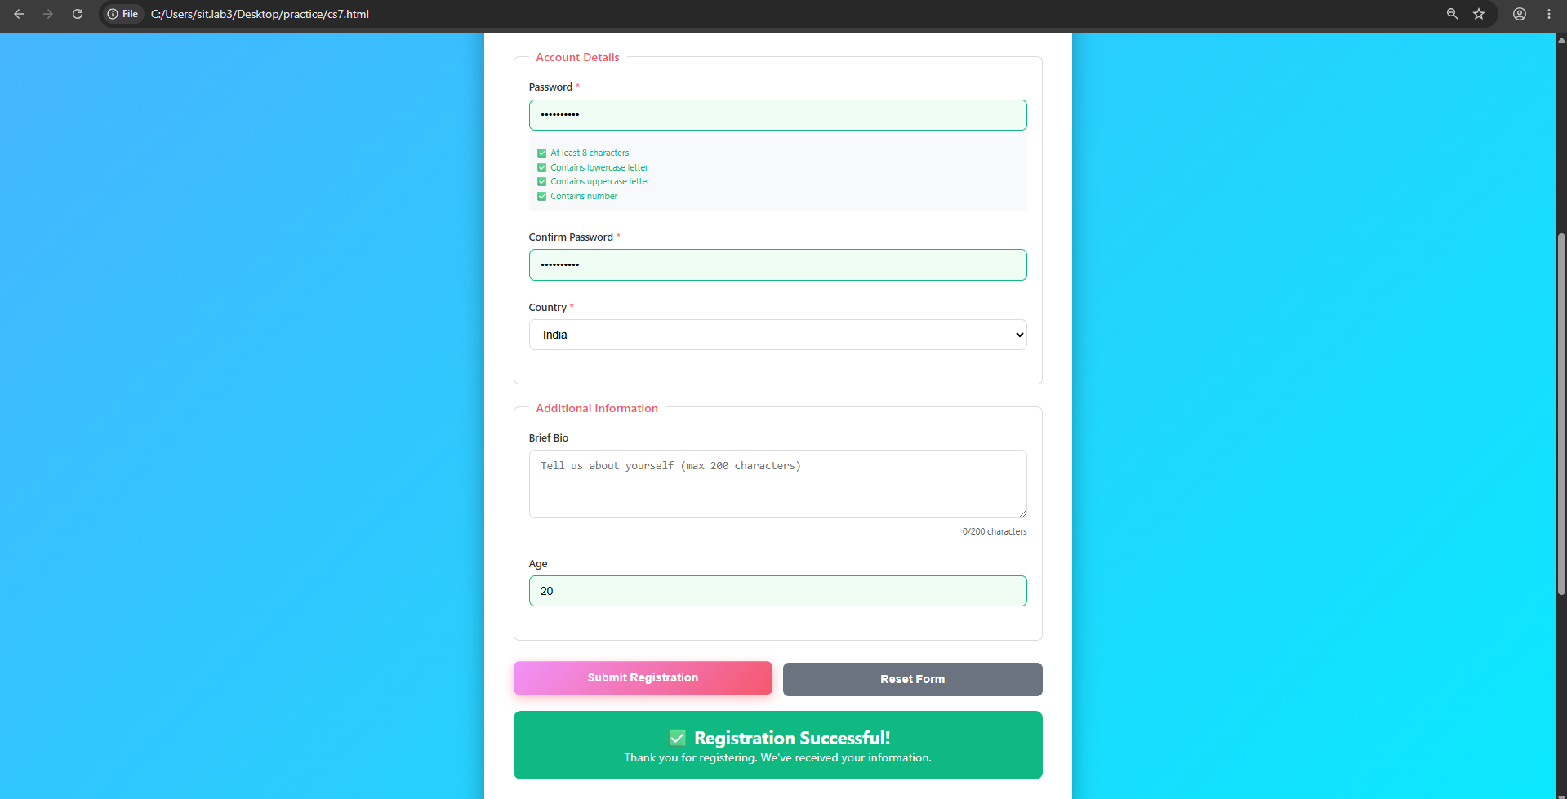
5. Result/Conclusion:
The experiment was successfully performed to study JavaScript event handling, form validation, and dynamic DOM manipulation. The form was validated and the output message was dynamically displayed using JavaScript.

EXPERIMENT 8
AIM:
Access and validate form fields using events; design a gym admission form with live input checks.
SOFTWARE/TOOLS REQUIRED:
- Visual Studio Code (VS Code)
- Google Chrome / Any Modern Web Browser
- HTML5
- JavaScript (ES6)
THEORY:
A form in HTML is used to collect information from users, such as name, age, email, phone number, gender, and membership type.
Form validation means checking whether the information entered by the user is correct and follows the required format before submitting the form.
JavaScript provides events that allow us to respond immediately to user actions.
Common events used for live validation are:
- input – occurs whenever the user types, deletes, or changes a field.
- change – occurs when the value of a field is changed.
- blur – occurs when the user leaves a field.
- submit – occurs when the user submits the form.

OUTPUT:
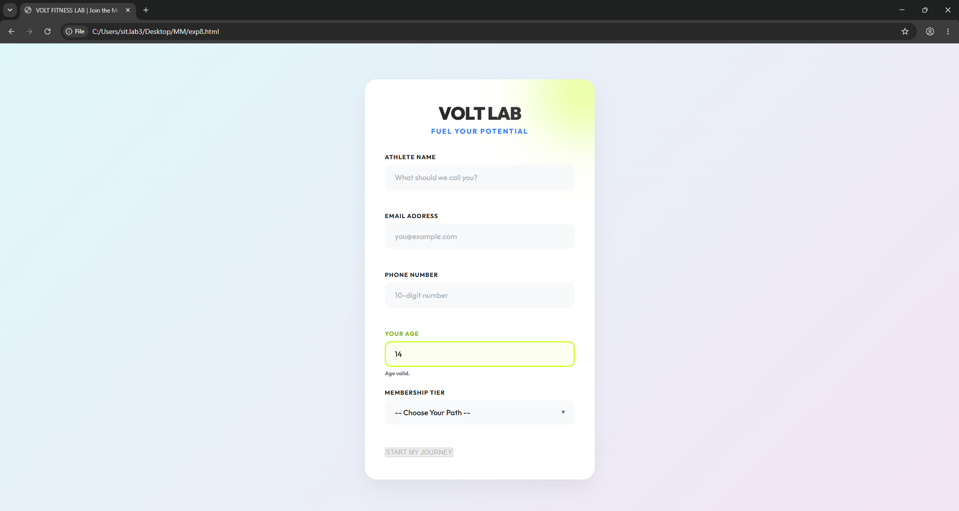
RESULT/CONCLUSION:
Thus, the gym admission form with live input validation was successfully created. The experiment demonstrated how JavaScript can access HTML form elements, handle user-generated events, and validate input dynamically. Live validation improves the accuracy of data entered into forms and provides immediate feedback to users, resulting in a more user-friendly and reliable web form.

Case Study 8
1. Experiment Title:
Design and Implementation of a Multi-Section Job Application Portal Using HTML5, CSS Grid, and JavaScript
2. Software/Tools Required:
- HTML5
- CSS3
- JavaScript
- Web Browser
- VS Code / any text editor
3. Experiment Program Code:
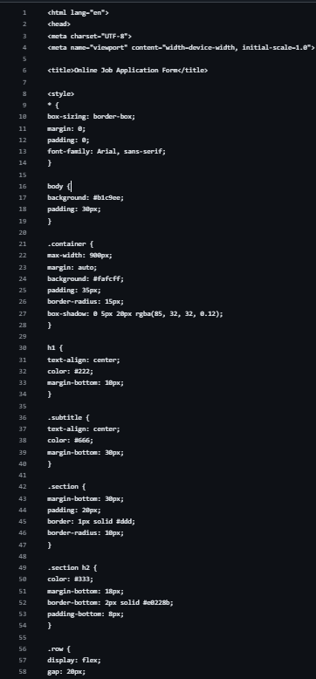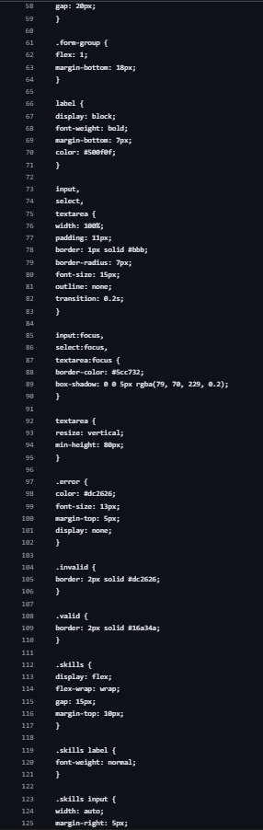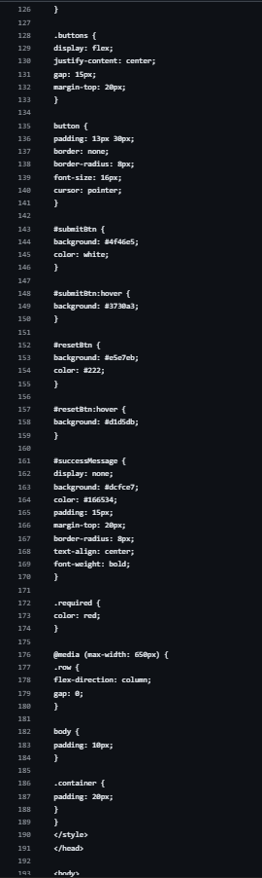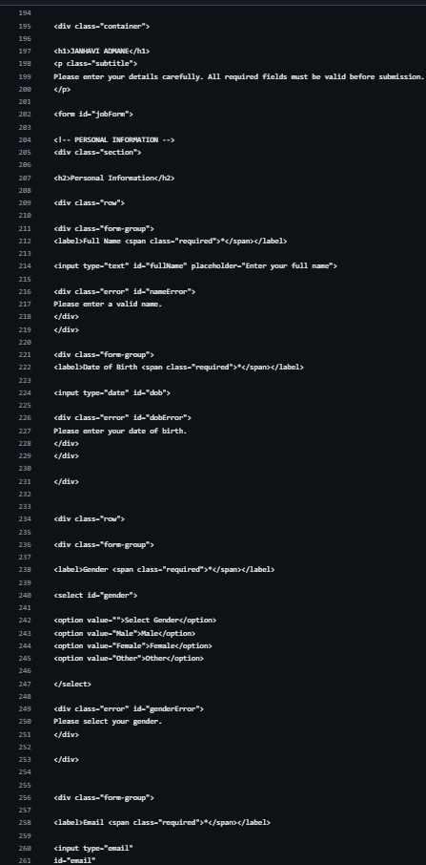
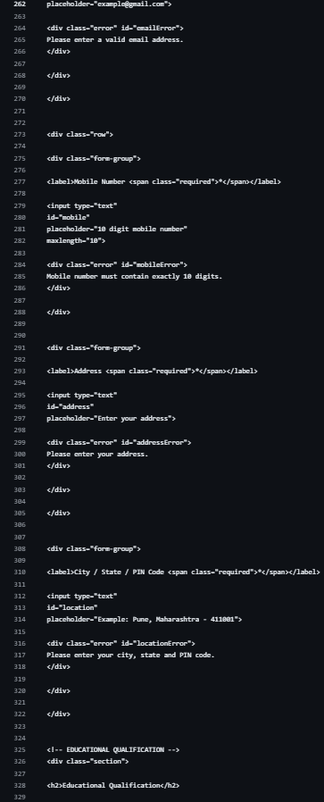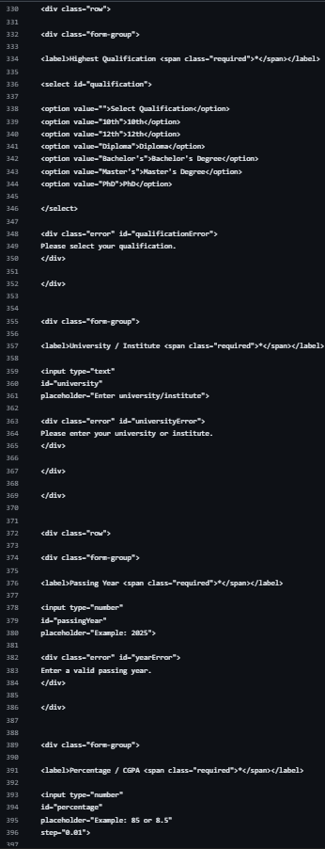
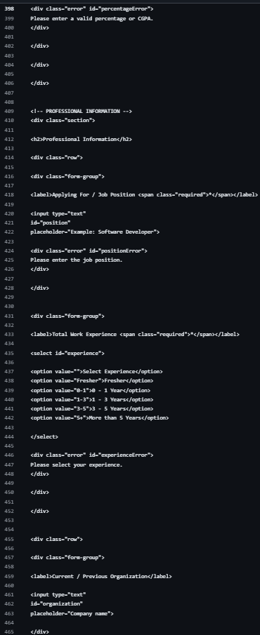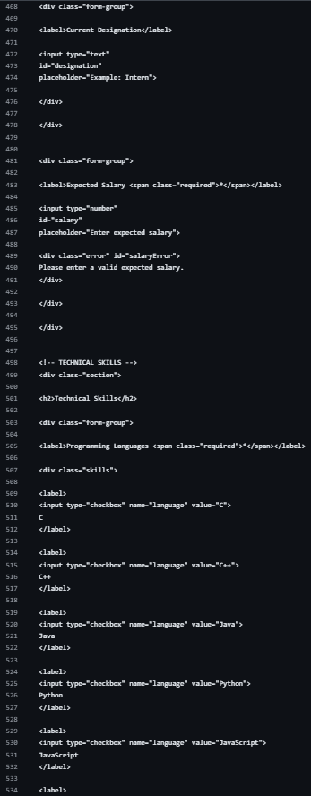
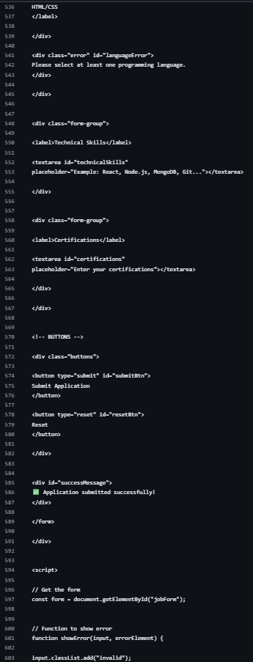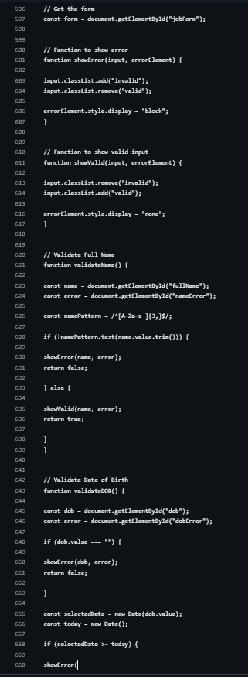

4.Output:
: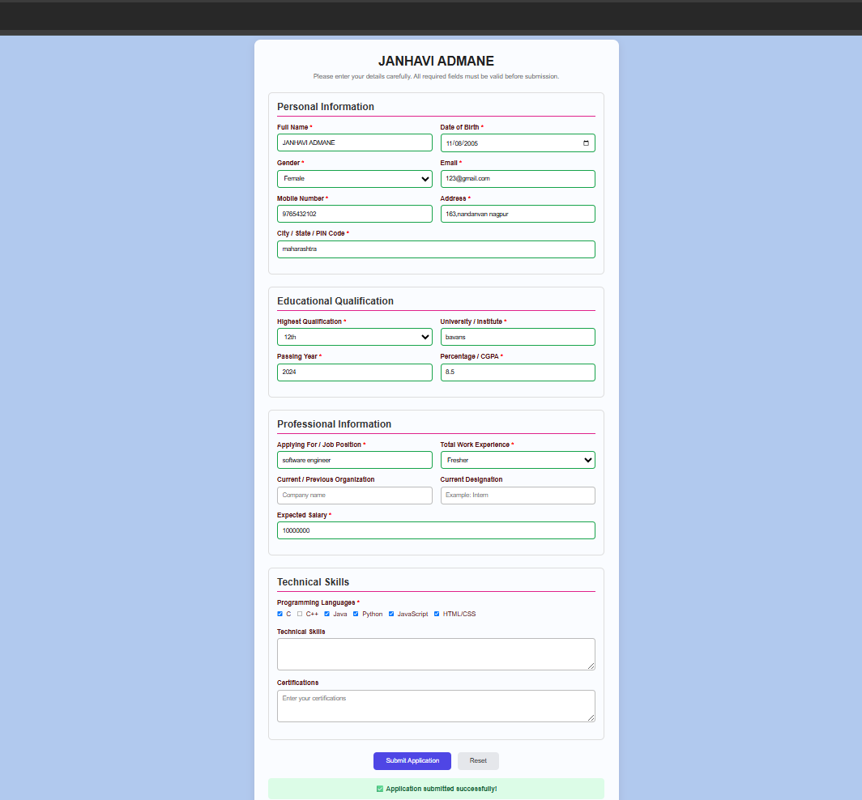
5. Result/Conclusion:
The experiment was successfully performed to design a multi-section job application portal using semantic HTML5 form elements, CSS Grid layout, and JavaScript form submission handling. The form was divided into logical sections and successfully validated and submitted using JavaScript.

EXPERIMENT 9
AIM:
Implement localStorage and sessionStorage to save user preferences like theme settings.
SOFTWARE/TOOLS REQUIRED:
- Visual Studio Code (VS Code)
- Google Chrome / Any Modern Web Browser
- HTML5
- JavaScript (ES6)
THEORY:
localStorage and sessionStorage are Web Storage APIs provided by JavaScript that allow websites to store data directly in the user's browser. localStorage stores data with no expiration time, so the saved information remains available even after the browser is closed and reopened.
sessionStorage, on the other hand, stores data only for the current browser session and is cleared when the browser tab or session is closed. Both storage methods store data in key-value pairs.
In this experiment, localStorage and sessionStorage are used to store user preferences such as theme settings. When the webpage is loaded, the stored preference can be retrieved and applied automatically, providing a personalized and consistent user experience.

OUTPUT:
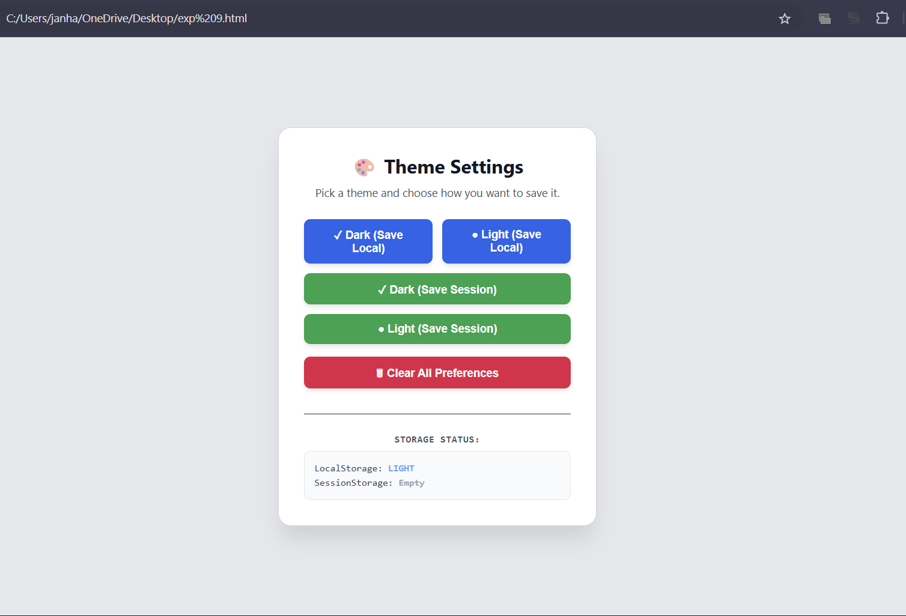

RESULT/CONCLUSION:
In conclusion, localStorage and sessionStorage were successfully implemented to store and manage user preferences such as theme settings. The experiment demonstrated the difference between persistent storage using localStorage and temporary session-based storage using sessionStorage. By saving preferences in browser storage, the application can remember user choices and apply them automatically, making the webpage more user-friendly and convenient.

EXPERIMENT 10
AIM:Loading and Displaying JSON Data Using Fetch API and jQuery $.getJSON().
SOFTWARE/TOOLS REQUIRED:
- HTML5
- CSS3
- JavaScript
- jQuery
- VS Code
- Web Browser (Google Chrome)
THEORY:
JSON (JavaScript Object Notation) is a lightweight data-interchange format commonly used to exchange data between a client and a server. It stores data in a structured key-value format and is easy to read and process.
The Fetch API is a modern JavaScript method used to request resources asynchronously, such as JSON files or data from an API. It returns a Promise that can be used to process the received response.
jQuery provides the $.getJSON() method, which is a simple way to retrieve JSON data asynchronously. After receiving the data, JavaScript or jQuery can be used to dynamically create HTML table rows and display the information on the webpage.
In this experiment, JSON data is loaded using both fetch() and jQuery $.getJSON(). The retrieved records are processed dynamically and displayed in an HTML table without manually writing each row.

OUTPUT:
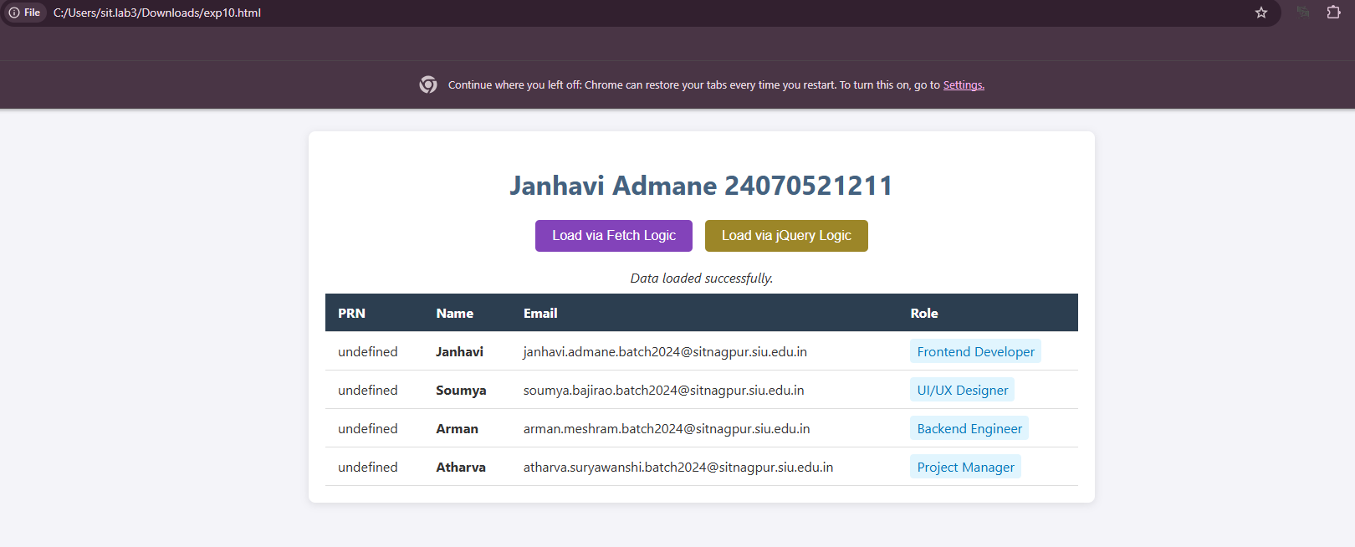
RESULT/CONCLUSION:
The experiment was successfully performed to load and retrieve JSON data using both the Fetch API and jQuery $.getJSON() method. The retrieved JSON records were dynamically processed and displayed in an HTML table. This demonstrates how asynchronous data retrieval can be used to create dynamic and interactive web pages.

